Title of the Paper (Capitalize First Letter)
Name SURNAME, Name SURNAME*
DOI: xxxxxxxxxxxxxx (to be inserted by the publishing house)
Abstract
[TNR, 10, italic, justify]. The content of the abstract should not exceed 300 words, authors are not allowed to use abbreviations or citations in the abstract. Please use normal capitalization within the text and do not use bold face for emphasis. Italics are acceptable. Do not use multiple columns. Do not include bullet lists or numbered lists unless absolutely necessary. Do not use more than three levels of heading. The abstract must include sufficient information for readers to judge the nature and significance of the topic. The abstract should be structured as follows: a) a brief introduction into the topic of the paper; b) an overview of the current state of the scientific literature on the topic; c) a presentation of research methodology and research questions; c) presentation of main results and the implications for the field; d) highlights of the contribution brought by the paper to the field of studies. The abstract does not substitute the introduction.

Keywords: first keyword, second keyword, third keyword, forth keyword, fifth keyword.

JEL Classification: Mention the code/codes according to the classification from http://www.aeaweb.org/jel/jel_class_system.php.
1. Introduction
The Chapter of Introduction should refer to the context of the research. Introduction states the objectives of the work and provides an adequate background, avoiding a detailed literature survey or a summary of the results.
For text, use TNR font, 11, left-right alignment, line spacing single, indent the first line of the paragraph to 0.5 cm and use Ctrl + A (for full selection of text) and then choose English language (United Kingdom).
For the chapter titles we will use TNR font, 12, bold, left alignment, hanging indentation 0.42 cm, spacing before: 12 point, after: 6 point, as can be seen in the screenshot below.
For the titles of the subchapters, we will use TNR font, 12, bold and italic, left alignment, indentation hanging 0.49 cm, spacing – before: 12 point, - after: 6 point, line spacing single.
All footnotes will be written in TNR font, 9, left-right alignment, indentation hanging 0.25 cm, line spacing single and each note ends with a period.

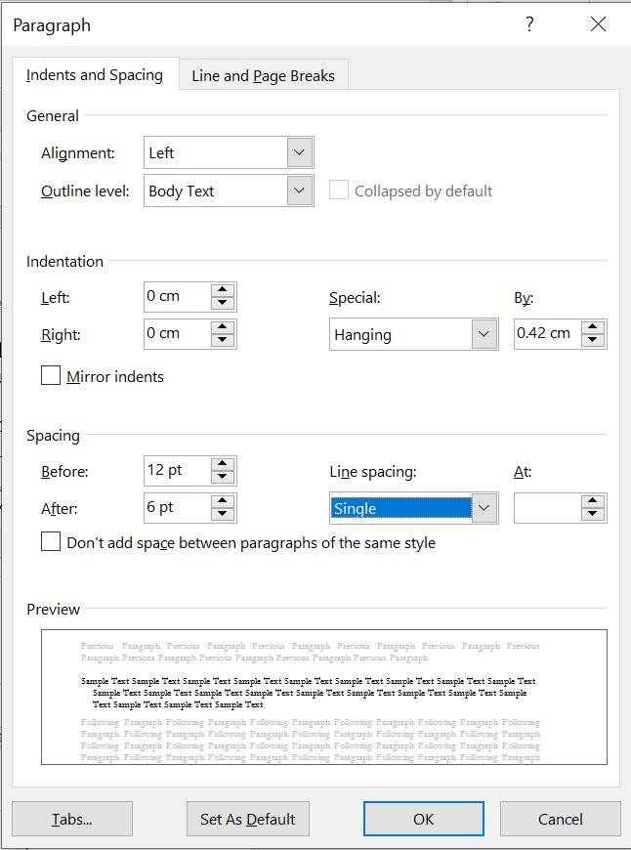
2. Problem Statement
This chapter should include an overview of the scientific literature in the field of the topic researched. The literature review should be synthesized, including the most important references to the topic.
The research gap should be highlighted in the context of the scientific literature, emphasizing the value added by the article (how is the article different from other similar ones, what novelty it brings to the field).
3. Research Questions/Aims of the Research
The research questions will operationalize the research problem, showing what part of the problem is being solved by this article’s contribution. If preferred, in this chapter there can also be presented the objectives of the research.
This chapter could include the Purpose of the Study, or Hypotheses, if the research is based on validating certain hypotheses.
4. Research Methods
In this chapter the author should present and discuss the research methods used in obtaining data/results. We suggest the detailing of the research methods, of the period of application, the means of application, the sample, methods, etc.
5. Findings
This chapter presents the results in a structured manner. The use of footnotes/endnotes is strictly forbidden.

5.1 Structure
Papers must be written in English and not exceed 10 pages (appendices included).
The minimum length of the paper is 5 pages.
The page numbering is done starting with page 1, TNR font, 10, centred.
The header cannot be modified.
The title of the article will be written in TNR font, 14, centred alignment, bold, single line spacing, before 18 points, after 12 points and capitalize each word, except the link words.
Bulleted lists may be included if absolutely necessary and should look like this:
- First point;
- Second point;
- And so on.

5.2 Tables
Tables submitted as pictures are not editable and may not be included. Tables need to be formatted in Word.
All tables should be numbered with Arabic numerals. Headings should be placed above tables, left justified. Tables must be embedded into the text and not supplied separately. Number tables consecutively in accordance with their appearance in the text. Below is an example which authors may find useful.

Table 1. An example of a table
An example of a column heading | Column A (t) | Column B (T)
And an entry | 1 | 2
And another entry | 3 | 4
And another entry | 5 | 6
Source: Hofstede, 2010 (Source is mandatory for each table!)

The title of the table will be written in TNR font, 10, bold, centred, spacing before 6 points, after 2 points, single line spacing. The source of the table (is mandatory) will be written in TNR font, 10 and only the word “source” will be written in italics, spacing before 2 points, single line spacing, as seen in the formatting of this template. If the table takes up several pages, then the table header will be repeated for each page, and it will be written bold, centred. All information in the table will be written in TNR font, 10 or less, depending on how many columns and rows there are, so that it can fit in the page and only vertical alignment will be used. Columns with text will line up to the left, and columns with numbers to the right.
Tables will be inserted centred (across the width of the page) and editable, only in special situations can image captures be allowed, for example, when they are made in another program and cannot be imported as editable tables.

5.3 Figures
Figures must be made in high quality, suitable for reproduction and print, taking into account necessary size reduction. Figures should be embedded in the text. A short descriptive title should appear under each figure. Mention the sources under the title. Number figures consecutively in accordance with their appearance in the text.
Figure 1. An example of a figure
Source: Adapted from Hofstede (2010) (Source is mandatory for each figure!)
The title of the figure will be written in TNR font, 10, bold, centred, spacing: before 2 points, single line. The source of the figure (is mandatory) will be written in TNR font, 10 and only the word “source” will be written in italics, single line, as seen in this template.
Figures and graphs will be inserted centred (across the width of the page) and editable (the graphs will be created with Calibri font, 8 for value axis, font Calibri 9 for legend text and axis titles). Only in special situations can image captures be allowed, for example, when they are made in another program and cannot be imported as editable figures.

5.4 Equations
Equations are left and numbered consecutively (see Equation 1), from 1 upwards. Please, use the point style for percentage numbers.

x₁ + x₂y = 10.7% (1)

The equations will be editable inserted and left-aligned. The right-alignment tabs will be used to number them, as shown in the previous model and in the next capture, if you look at the ruler and have the Show All button active (Hide / Show).

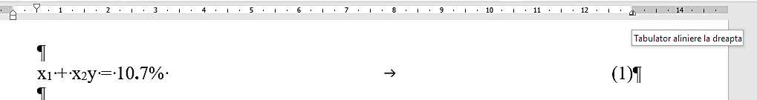

5.5 Construction of References
References should be listed at the end of the paper in alphabetical order. Authors should ensure that every reference in the text appears in the list of references and vice versa. When publications are referred in the text, enclose the author’s name and the date of publication within the brackets.
For one author, use author’s surname and the year: (Aron, 2002) or “…as Aron (2002) demonstrated”.
For two authors, give both names and the year: (Allain & Kravic, 2005) or „Allain and Kravic (2005) have recently shown .... ”
For three or more authors, use the first author plus “et al.”, and the date (Liam et al., 1996).
For legal regulations and laws, organizations use abbreviated name and year (between round brackets): (INS, 2008) or „..according INS (2008)...”
Citations of groups of references should be listed alphabetically: „...as demonstrated (Aron, 2002; Liam et al., 1996)…”
The full URL should be given in text as a citation, if no other data are known.
If the authors, year, title of the documents are known and the reference is taken from a website, the URL address has to be mentioned after these data.
6. Conclusions
The chapter of conclusions should answer the research questions, discuss the issue of validity, credibility, limits of the study, generalizing the data etc. In case of hypotheses, it should present whether they were validated or not.

Acknowledgment
Include acknowledgment in a separate section at the end of the paper before the references and do not, therefore, include them on the title page, as a footnote to the title or otherwise.
References
All references cited in the text must be included in the reference list at the end of the manuscript, and every reference in the list must be cited in the text.
In-text citation should be in brackets.
References should be listed alphabetically by author. For more than one publication by an author, arrange by publication date with the earliest publication first.

[Nº] Author, A. A., Author, B. B., & Author, C. C. (year). Title of article. Title of Journal, Volume No. (Issue No.), pp-pp.
[Nº] Surname, A. A. (year). Title of work. Location: Publisher.
[Nº] Surname, A. A. (year). Title of work. Retrieved from http://www.
[Nº] Author, A. A., & Author, B. B. (year). Title of chapter or entry. In A. Editor, B. Editor, & C.
[Nº] Editor (Eds.), Title of book (pp. xxx-xxx). Location: Publisher.
[Nº] Author, A. A., & Author, B. B. (year). Title of chapter or entry. In A. Editor & B. Editor (Eds.), Title of book (pp. xxx-xxx). Retrieved from http://www.
[Nº] Author, A. A., Author, B. B., & Author, C. C. (year). Title of article [Title of article English translation]. Title of Journal, Volume No. (Issue No.), pp-pp.
[Nº] Author, A. A. (year). Title of work original language [Title of work English translation]. Location: Publisher.

The entire list of references will be written in TNR font, 10, left-right alignment, indentation hanging 0.5 cm, spacing after 3 points, single row spacing and each reference in the list ends with a period, as can be seen in the list of the following references.
Example:
- Alpopi, C., Burlacu, S. & Ioviţu, M. (2018). Procesul de globalizare şi politicile ecologice [The process of globalization and environmental policies]. In: Competitivitatea şi Inovarea în Economia Cunoaşterii [Competitiveness and Innovation in the
Knowledge Economy], 2, 28-29 September 2018, Chișinău, Republica Moldova: Departamentul Editorial-Poligrafic al ASEM [Editorial-Polygraphic Department of ASEM], pp. 317-324.
- Angheluta, S. P., Burlacu, S., Diaconu, A. & Curea, C. S. (2019). The Energy from Renewable Sources in the European Union: Achieving the Goals. European Journal of Sustainable Development, 8(5), 57.
- Bodislav, A. D., Rădulescu, C. V., Moise, D. & Burlacu, S. (2019). Environmental Policy in the Romanian Public Sector. The Bucharest University of Economic Studies Publishing House, 312.
- Bran, F., Rădulescu, C. V., Bodislav, D. A. & Burlacu, S. (2019). The Anthropic Pressure on the Forest Space. Dysfunctions and Risks in Romania. Quality-Access to Success, 20.
- Bran, F., Alpopi, C. & Burlacu, S. (2018). Territorial Development-Disparities between the Developed and the least Developed Areas of Romania. LUMEN Proceedings, 6(1), pp. 146-155.
- Bran, F., Burlacu, S. & Alpopi, C. (2018). Urban Transport of Passengers in Large Urban Agglomerations and Sustainable Development. Experience of Bucharest Municipality in Romania. European Journal of Sustainable Development, 7(3), pp. 265-273.
- Bran, F., Manea, G., Ioan, I., Rădulescu, C. (2006). Economia în clepsidra antropică, [The economy through the entropic hourglass]. Bucharest: Economica Publishing.
- Bran, P. (1994). Finanțele întreprinderii. Gestiunea fenomenului microfinancier [Company’ finance. The management of the the micro-financing phenomenon], Bucharest: Ecnomica Publishing.
- Bran, P. (2009). Managementul prin valoare [Value based management], Bucharest: Universitara Publishing.
- Comisia Europeană COM (2017). Reflection Document on the Valorization of Globalization Opportunities, No 240 / 10 May 2017.
- Dima, C., Burlacu, S. & Buzoianu, O. A. C. (2020). Strategic Options for the Development of Ecotourism in the Danube Delta in the Context of Globalization. In SHS Web of Conferences, 74, p. 04005. EDP Sciences.
- Jianu, I., Dobre, I., Bodislav, D. A., Radulescu, C. V. & Burlacu, S. (2019). The Implications of Institutional Specificities on the Income Inequalities Drivers In European Union. Economic Computation and Economic Cybernetics Studies and Research, 53(2), pp. 59-76.
- Negescu Oancea, M. D., Burlacu, S., Buzoianu, O. A. C., Mitrita, M. & Diaconu, A. (2019). Strategic Options for the Development of Ecoturism in the Dornelor County. The USV Annals of Economics and Public Administration, 19(1 (29)), pp. 21-28.
- Rădulescu, C. V., Bodislav, D. A. & Burlacu, S. (2018). Demographic Explosion and it Governance in Public Institutions. Managerial Challenges of the Contemporary Society. Proceedings, 11(1), p. 18.
- Peptenatu, D., Pintilii, R. D. & Draghici, C. (2011). Environmental Risk Management
of Urban Growth Poles Regarding National Importance. Int. J. Environ. Sci. Technol, 8, pp. 737-746.
- Pop, N., Ioan-Franc, V. (2018). Romania in globalization: argumentation, attitude, action and responsibility, Economic Information and Documentation Center Publishing House.
- Rădulescu, C. V., Dobrea, R. C. & Burlacu, S. (2018). The Business Management of Distress Situations. The 12th international management conference Management Perspectives in the Digital Era, November 1st-2nd, Bucharest, Romania, 1, pp. 741-747.
Appendix (if needed)

Please note that submissions not complying with these guidelines will be rejected on formal grounds!

Recommendations:
*All the articles will be subjected to a double-blind peer review process

Title
The title of the paper should accurately reflect the content of the article and should be in accordance with the scientific focus of the conference. Because search engines grant the highest importance to the titles of papers, it is crucial that our authors include in the title words that should be probably used by the readers in order to search articles on the same topic. The title needs to be short (8-10 words) and contain the most important keywords of the article and illustrate the research questions rather than the research methodology. Authors should avoid superfluous words such as “A study of…”, “An analysis of…”.

Abstract
The abstract of the paper has to contain enough information for the reader to be able to appreciate the nature and the significance of the subject. For increasing the visibility of the article, it has to reiterate keywords and phrases which define the article but still, in a manner such as to avoid unnecessary repetitions. Make use of all the 300 words allocated for the abstract section and present as many details as possible to convince scholars to read the article. The abstract should be structured as follows: a) a brief introduction into the topic of the paper; b) an overview of the current state of the scientific literature on the topic; c) a presentation of research methodology and research questions; c) presentation of main results and the implications for the field; d) highlights of the contribution brought by the paper to the field of studies.

Keywords
The keywords should be listed in decreasing order of importance meant to reveal the essence of the paper and should be consistent with the title and abstract of the article. The number of keywords should be between 5-7.

Introduction
The introduction is meant to familiarize the reader with the content of the paper by reiterating the keywords. It has to deliver the purpose of the paper, state initial hypotheses, properly summarize the literature, refer to previous research, and in the last it should refer to the aspects that are to be addressed in the body of the article.

Body of the article
The article has to be the result of a research in the fields addressed by the scope of the conference. The structure of the has to be logical and clearly laid out through titles, and subtitles. In order to ease the access of the reader to the content, the article should follow the structure: Literature review, Research methodology (should provide sufficient information to make the research replicable, data collections should be emphasised, sampling appropriate, results should be logically presented, statistics correct, all the analysis should be appropriate), Results and discussion.

Conclusions
Conclusions are necessary and they have the purpose of making a synthesis of the paper, of underlining its importance and contributions, of indicating eventual limitations and future lines of research. The claims in the conclusion section should be reasonable and supported, authors should relate to initial hypotheses; the conclusions should also explain how the article contributes to knowledge advancements.

The language should be accurate and well mastered. The editors are not liable for language editing or for the correctness of the research of the authors. This is the responsibility of the authors. In case the authors do not have English as their first language, we invite them to use the professional editing services delivered by the company 112Edit (www.112Edit.com) or www.editage.com. Moreover, authors having their names written in diacritics should pay close attention to the spelling of their name and should make sure they write the authors’ names correctly – First Name, LAST NAME. Any errors in spelling their names may be conducive to their being indexed wrongly which can ultimately lead to a potential decrease in the number of citations.
General editing/formatting requirements: The body of the article should be written with the font style Cambria Headings, 12, single spaced, justified (except for titles, tables and figures; for the full editing requirements, please see the Authors’ template document), the word count should be: 3000-4000 words; page margins: all margins 2.5 cm.

Author’s affiliation, City, Country, e-mail address.
Author’s affiliation, City, Country, e-mail address. * Corresponding author.

